Spring Bean Scopes — Case-Study Based Deep Dive
What Is a Spring Bean Scope?
A bean scope defines:
- How many instances of a bean are created
- When they are created (eager / lazy)
- Whether the same instance is reused or a new one is created
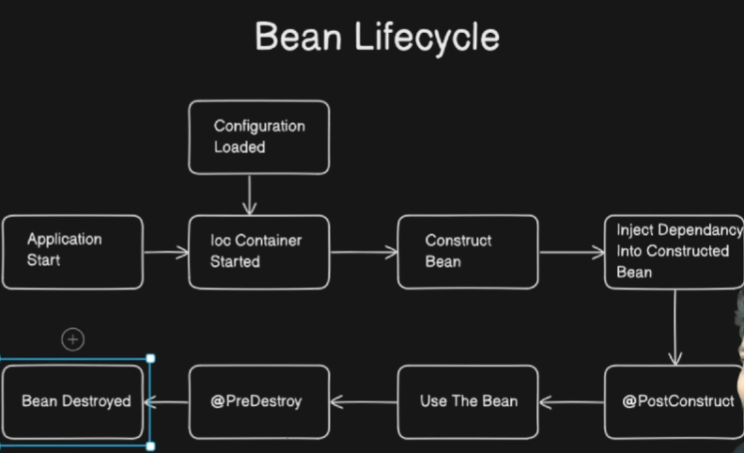
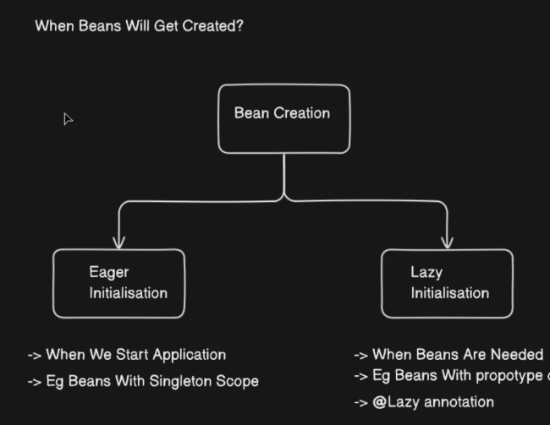

Spring provides 4 main scopes:
Scope | Instances | Initialization
Singleton | One per container | Eager
Prototype | New every time | Lazy
Request | One per HTTP request | Lazy
Session | One per HTTP session | Lazy

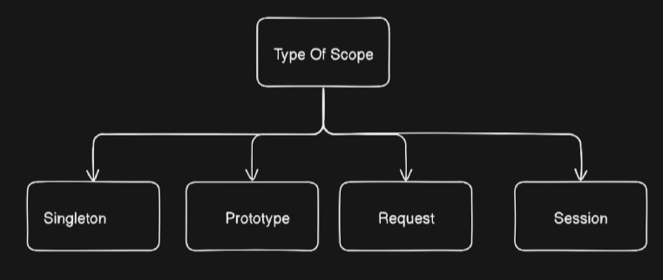

Common Base Application (Used in All Cases)
Spring Boot Application
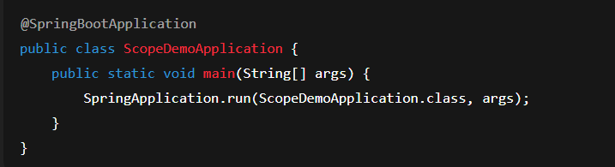

BASE ENTITIES (No Scope Yet)
User Entity
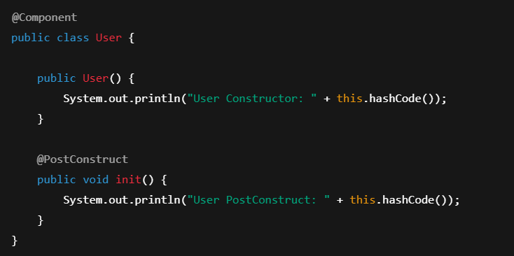
Employee Entity
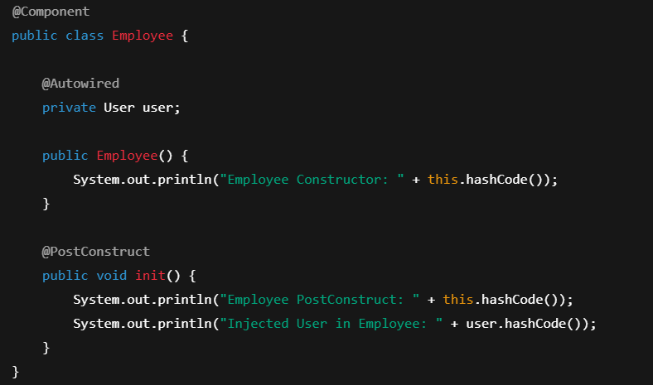

UserController
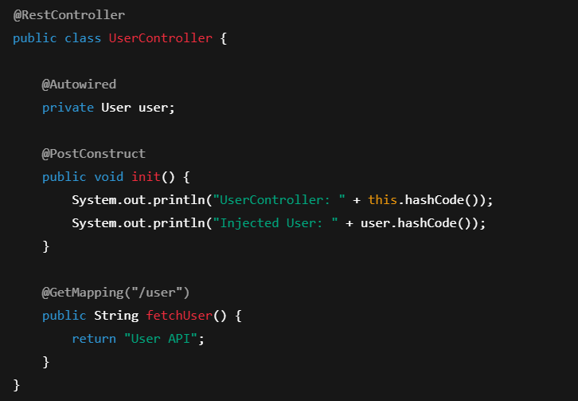
EmployeeController
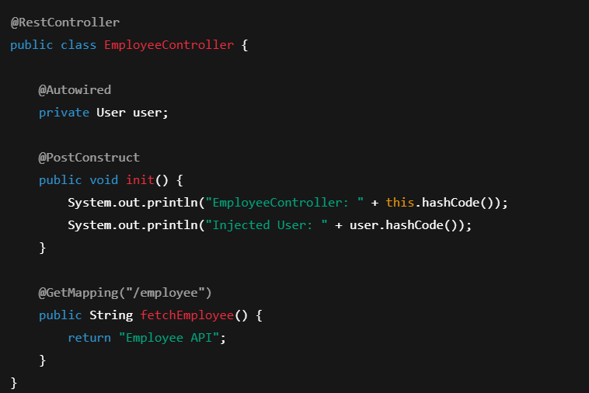
CASE 1 — SINGLETON SCOPE (DEFAULT)
Scope Setup
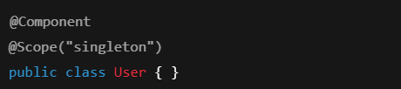
(All controllers & Employee remain singleton)

Application Startup Flow
- Spring container starts
- Singleton beans are created eagerly
- User bean created once
- EmployeeController created → same User injected
- UserController created → same User injected

Console Output Pattern
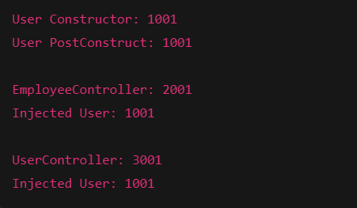
✔ Same User everywhere
✔ Created only once

API Calls
- /user → same User
- /employee → same User
- Multiple calls → no new User
Conclusion (Singleton)
- One bean per container
- Eager initialization
- Default Spring behavior

CASE 2 — PROTOTYPE SCOPE
Case 2A — Employee Singleton, User Prototype
Scope Setup
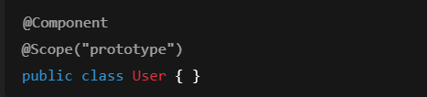
Employee → singleton
Controllers → prototype
Application Startup
- Employee created
- Needs User → User created
- Controllers not created yet (lazy)
API Call: /employee
- EmployeeController created
- User dependency → new User created
- Employee reused (singleton)
API Call: /user
- UserController created
- User dependency → new User created
Observation
- User hashCode changes every time
- Employee hashCode remains same

Case 2B — Employee ALSO Prototype
Scope Setup
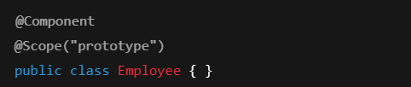
User → prototype
Controllers → prototype
Application Startup
✔ No beans created
Every API Call
- New controller
- New employee
- New user
✔ Everything recreated
Conclusion (Prototype)
- Lazy initialization
- New instance per injection
- Spring does NOT manage destruction

CASE 3 — REQUEST SCOPE
Scope Setup
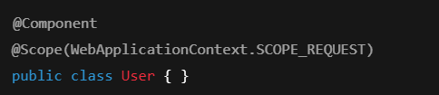
Employee → prototype
Controllers → request
Application Startup
✔ No beans created
API Call: /employee (Single Request)
- Request starts
- EmployeeController created
- User created (request-scoped)
- Employee created
- Employee needs User → same User reused
- Request ends → beans destroyed
Key Point
- Same User within one request
- New User for next request

TRICKY CASE — Request Bean Inside Singleton
Setup
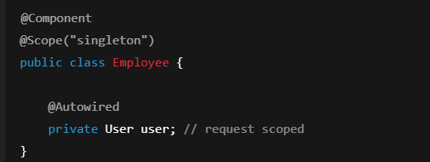

What Happens?
❌ Application fails at startup
Reason:
- Singleton created at startup
- No HTTP request exists
- Request bean cannot be injected
Solution — Proxy Mode
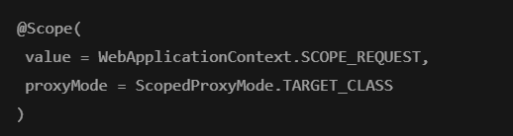
Spring injects a proxy, not the real bean.
Conclusion (Request)
- One bean per HTTP request
- Proxy required when injecting into singleton

CASE 4 — SESSION SCOPE
Scope Setup
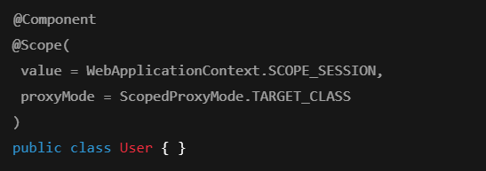
Behavior
- One User per session
- Same User across multiple requests
- New session → new User

Interview-Critical Takeaways
- Singleton ≠ one object for JVM
- Prototype beans are not destroyed by Spring
- Request/Session require proxyMode
- Scope mismatch causes startup failure
- HashCode logging is best verification technique

One-Line Interview Answer
“Spring bean scope defines how many instances of a bean exist and how long they live inside the container.”
This version is intentionally redundant, code-heavy, and case-driven — exactly the kind of document people bookmark and revisit.

